**LAB 4**



Session: 2021 – 2024

**Submitted by:**

Muhammad Hamza 2021-CS-178

**Supervised by:**

Mam Bushra

Department of Computer Science

**University of Engineering and Technology**

**Lahore Pakistan**

**PING COMMAD**

Test network connectivity by sending ICMP echo requests.

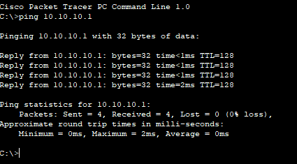

**ENABLE**

Enter privileged exec mode to access advanced commands.

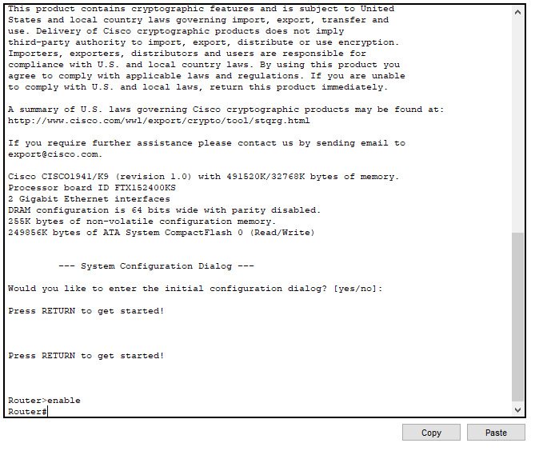

**Configure Terminal**

Enter global configuration mode to configure router settings.

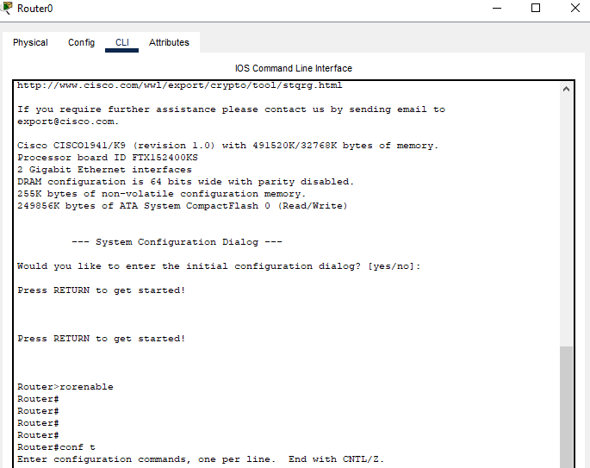

**HostName**

Set host name for your network. Just like your name.

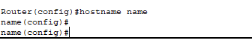

**Exit**

You can use the "exit" command to exit back to privileged exec mode.

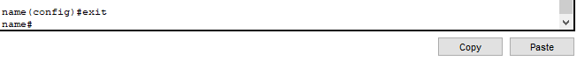

**Write Memory**

The command "write memory" is used in Cisco IOS (Internetwork Operating System) to save the running configuration of a router or switch to the startup configuration file, effectively saving any changes made to the device's configuration. This command is also often abbreviated as "wr" or "copy running-config startup-config.

